**TABLE CREATION:**

CREATE TABLE EventPlanLine

(PlanNo VARCHAR2(8) CONSTRAINT EPlanNoNotNull NOT NULL,

LineNo VARCHAR2(8) CONSTRAINT LineNoNotNull NOT NULL,

TimeStart DATE CONSTRAINT TimeStartNotNull NOT NULL,

TimeEnd DATE CONSTRAINT TimeEndNotNull NOT NULL,

Numberfld INT CONSTRAINT NumberfldNotNull NOT NULL,

LocNo VARCHAR2(8) CONSTRAINT ELocNoNotNull NOT NULL,

ResNo VARCHAR2(8) CONSTRAINT EResNoNotNull NOT NULL,

CONSTRAINT CHECK_TIME CHECK (TimeStart < TimeEnd),

CONSTRAINT PK_EVENTPLANLINE PRIMARY KEY (PlanNo,LineNo),

CONSTRAINT FK_PLANNO FOREIGN KEY (PlanNo) REFERENCES EVENTPLAN (PlanNo),

CONSTRAINT FK_LOCNO FOREIGN KEY (LocNo) REFERENCES LOCATION (LocNo),

CONSTRAINT FK_RESNO FOREIGN KEY (ResNo) REFERENCES RESOURCETBL (ResNo));

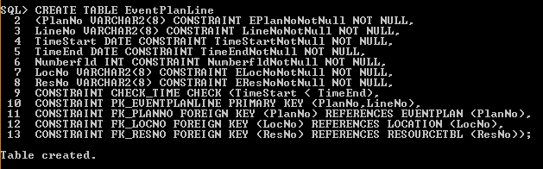

**SELECT STATEMENT:**

